Scope Management Plan Date:10 dec 2025

Project Name: FixIt Jo – Mobile Application for Connecting Users with Local Craftsmen Using GPS and AI Chatbot

Introduction
The Scope Management Plan defines how the scope of the FixIt Jo project will be identified, defined, validated, and controlled throughout the project lifecycle. The purpose of this plan is to ensure that all required work—and only the required work—is included in the project. Proper scope management will help prevent scope creep, ensure alignment with academic requirements, and support successful delivery of the project within the defined time and budget constraints.
This plan is based on the approved Business Case, Project Charter, and Kick-Off Meeting outcomes.

Preparing the Scope Statement
The project scope statement clearly defines what is included and excluded in the FixIt Jo project.
In-Scope:
- Mobile application for customers and service providers
- Registration & login for both user types
- Categorized service selection
- Location-based requests (within Amman)
- Basic chatbot support
- Service requests & notifications
- Worker profiles (skills, availability, pricing)
- Customer ratings and feedback

Out-of-Scope:
- Online payment and billing integration.
- Advanced AI-based recommendations and predictive analytics.
- Provision of services outside the geographical region of Amman.
- Web-based platform development (the current implementation is mobile application only).
- Integration with governmental services or business licensing systems.
The scope statement will serve as a reference for all project decisions and deliverables.

Creating the Work Breakdown Structure (WBS)
The Work Breakdown Structure (WBS) breaks down the project into manageable components to improve planning, execution, and control.
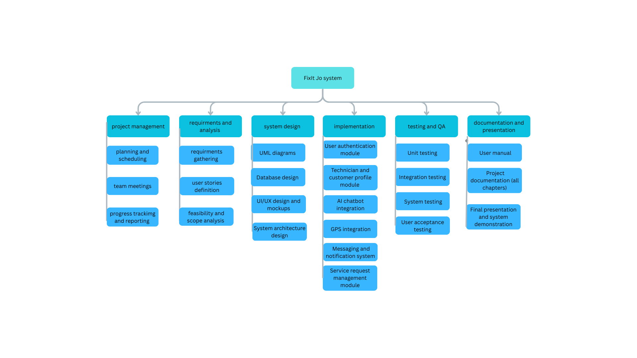
The WBS will be used as the basis for scheduling, cost estimation, and task assignment.

Verifying Completion of Project Deliverables
Verification of project deliverables ensures that all scope requirements have been
met.
- Deliverables will be reviewed against the approved scope statement and success criteria defined in the Project Charter.
- Supervisors will review and approve major deliverables, including documentation, system features, and final presentation.
- User acceptance testing results will be used to validate system functionality and quality.
- A delivery is considered complete only after formal approval by the project supervisors.

Managing Requests for Changes to Project Scope
Scope changes will be managed through a formal change control process to avoid scope creep.
- Any proposed change must be documented and submitted to the project team leader.
- The change request will be evaluated based on its impact on time, cost, quality, and academic requirements.
- Significant changes must be reviewed and approved by the project supervisors.
- Approved changes will be reflected in updated project documents, including scope statement, schedule, and WBS.
- Unapproved changes will not be implemented.

This structured approach ensures that the FixIt Jo project remains controlled, focused, and aligned with its original objectives.

